- What are different types of software testing? Explain the black-box testing and white-box testing.
Software testing is a systematic process of evaluating software to identify defects and verify whether it satisfies specified requirements.
For example, consider a Room Rent Management System developed using Java. The system may allow:
- Tenant registration
- Room management
- Room allocation
- Rent calculation
- Rent payment
- Complaint management
- Payment history
- Admin management
Testing ensures that these functions work correctly and reliably.

. Based on Testing Level
- Unit Testing
- Integration Testing
- System Testing
- Acceptance Testing

2. Based on Testing Technique
- Black-Box Testing
- White-Box Testing

3. Based on Testing Purpose
- Regression Testing
- Smoke Testing
- Stress Testing
- Performance Testing
- Security Testing
- Alpha Testing
- Beta Testing

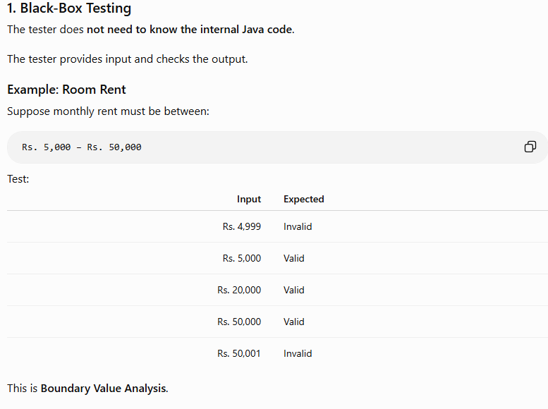
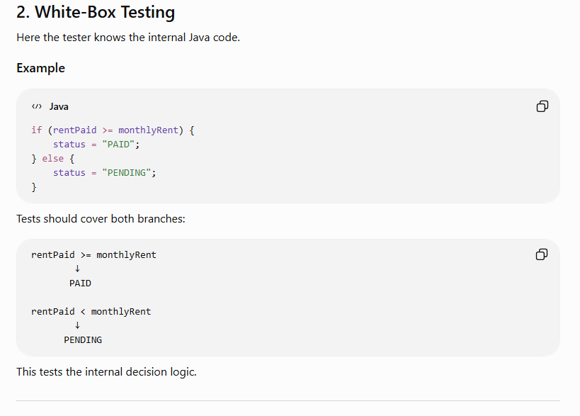
- What is a software configuration item (CI)? How are configuration items managed throughout the software development lifecycle? Explain the importance and key objectives of configuration management in software engineering.

Software Configuration Item (SCI) and Configuration Management

1. What is a Software Configuration Item?
A Software Configuration Item (SCI), often simply called a Configuration Item (CI), is a named element of information created during the software engineering process and treated as a single entity for configuration management.
A CI can range from a small item, such as a test case or UML diagram, to a complete SRS document or software system.

Examples of Configuration Items
- Software Code
  - Java source code
  - Object code
  - Configuration files
- Documentation
  - SRS
  - Design documents
  - Project schedules
  - User manuals
- Testing Artifacts
  - Test plans
  - Test cases
  - Test procedures
  - Test results
- Data
  - Database
  - Database schemas
  - Data structures
- Software Tools
  - Compiler versions
  - Editors
  - Libraries
  - Development environments

Example: Room Rent Management System
Room Rent Management System
│
┌─────┼──────┐
↓ ↓ ↓
Code Docs Tests
│ │ │
Java SRS Test Cases
Files UML Test Reports

2. How are Configuration Items Managed?
Configuration items are managed throughout the SDLC using Software Configuration Management (SCM).
SCM starts from the beginning of development and continues until the software is retired.
The major activities are:

1. Configuration Identification
First, all CIs are identified, named, and organized.
For example:
- Tenant.java
- Room.java
- RentService.java
- database.sql
- SRS.pdf
- RentCalculationTest.java
Each item is given a unique identity so that it can be tracked.

2. Version Control
Version control manages different versions of configuration items.
Tools such as Git maintain the history of changes.
Version 1.0
↓
Version 1.1
↓
Version 1.2
Developers can determine:
- Who made the change
- When it was made
- What was changed
- Previous versions
If a new version fails, the team can rollback to a previous stable version.

3. Change Control
Changes should not be made randomly.
A typical process is:
Change Request
↓
Impact Analysis
↓
Approval
↓
Implementation
↓
Testing
↓
Release
For example, in a Room Rent System, a landlord requests:
"Add online rent payment."
The team analyzes how the change will affect Payment, RentService, database tables, test cases, and other components.
If approved, the change is implemented and tested.

4. Configuration Auditing
Configuration auditing verifies that changes have been implemented correctly and that the software configuration follows the approved requirements.
It checks whether:
- The requested change was implemented.
- Unapproved changes were not introduced.
- Related CIs were properly updated.
- The correct version is included in the release.

5. Status Reporting
Status reporting, also called configuration status accounting, records information about configuration items and their changes.
It answers questions such as:
- What version is currently available?
- Who changed it?
- When was it changed?
- What changes were made?
- Which release contains the change?

3. Baseline
A baseline is a configuration item or collection of configuration items that has been formally reviewed and approved and serves as a foundation for further development.
Once a CI becomes part of a baseline, it cannot normally be changed without following the formal change control process.
Example:
Room Rent System v1.0
↓
Review & Approval
↓
BASELINE
↓
Future Changes

4. Importance of Configuration Management
Software changes continuously during development and maintenance. Without proper configuration management, uncontrolled changes can create confusion, conflicts, defects, and inconsistent versions.

1. Prevents Chaos
SCM controls changes and prevents uncontrolled modifications.

2. Maintains Version History
It preserves previous versions and allows rollback when necessary.

3. Provides Traceability
It connects changes with requirements, code, tests, and releases.
Requirement
↓
Change Request
↓
Code Change
↓
Test Case
↓
Software Release

4. Maintains Integrity and Consistency
It ensures that the correct versions of software components are used across development, testing, and production environments.

5. Supports Reproducibility
SCM helps ensure that the same source code, dependencies, configuration, and build information can produce a consistent software build.

6. Supports Team Collaboration
Multiple developers can work on the same project using repositories, branches, and merging.

7. Supports Quality
Controlled changes, testing, and auditing help maintain software quality throughout its evolution.

8. Supports Compliance
Configuration management provides records and audit trails that can help organizations meet required standards and processes.

5. Key Objectives of Configuration Management
The major objectives are:

1. Identification
To clearly identify all items that collectively represent the software configuration.

2. Change Management
To control how, when, and why changes are made.

3. Version Construction
To manage and assemble different versions and releases of the software.

4. Quality Maintenance
To ensure that software quality and consistency are maintained as the system evolves.

5. Traceability
To track the relationship between requirements, configuration items, changes, tests, and releases.

6. Room Rent System Example
Suppose Room Rent Management System v1.0 is already released.
The landlord requests:
"Add online rent payment."
The SCM process would be:
Change Request
↓
Impact Analysis
↓
CCA Approval
↓
Create New Version/Branch
↓
Modify Java Code
↓
Update Database
↓
Update Test Cases
↓
Testing
↓
Configuration Audit
↓
New Baseline
↓
Release v1.1
If v1.1 introduces a serious problem:
v1.1 ✗
↓
Rollback
↓
v1.0 ✓
This demonstrates how configuration management allows changes while maintaining control, traceability, and software quality.

7. Summary Table
SCM Activity | Purpose
Identification | Identifies and names configuration items
Version Control | Maintains different versions
Change Control | Controls modifications
Baseline | Provides an approved stable reference
Status Reporting | Records configuration history and status
Configuration Auditing | Verifies correctness and completeness
Build/Release Management | Creates and delivers consistent releases

Conclusion
A Software Configuration Item is a named software work product that is treated as a single entity for configuration management. Software Configuration Management manages these items through identification, version control, change control, baselining, auditing, and status reporting. Its main objectives are to control changes, maintain version consistency, provide traceability, support reproducible releases, and preserve software quality throughout the SDLC.

- What is Change Management in software development? Explain the key steps involved in managing change requests, and discuss how version and release management ensure software stability

Change Management in Software Development

1. What is Change Management?
Change Management in software development is a systematic process of identifying, evaluating, approving, implementing, testing, and controlling changes to software throughout its life cycle.
Changes may occur because of:
- New customer requirements
- Bug fixes
- Security requirements
- Business changes
- Technology changes
- Performance improvements
It is an important part of Software Configuration Management (SCM) and helps minimize mistakes caused by uncontrolled changes.
Simple definition: Change management ensures that software changes are made in a controlled, systematic, and traceable manner without disturbing existing functionality.

2. Key Steps in Managing Change Requests
The typical change management process is:
Change Request
↓
Assessment & Impact Analysis
↓
Approval / Rejection
↓
Engineering Change Order
↓
Implementation
↓
Testing & Review
↓
Check-in
↓
Release / New Baseline

Step 1: Submission of Change Request
A user, customer, tester, or developer identifies a required change and submits a Change Request (CR).

Example — Room Rent System
A landlord requests:
"Add online rent payment to the Room Rent Management System."
The request identifies the required feature and affected configuration items.

Step 2: Assessment and Impact Analysis
The development team evaluates:
- Technical feasibility
- Cost
- Time
- Risks
- Effect on existing features
- Affected configuration items
For example, online payment may affect:
- PaymentService.java
- RentService.java
- Tenant.java
- Database
- Payment interface
- Test cases

Step 3: Approval or Rejection
A Change Control Authority (CCA) or responsible project authority reviews the request.
The request may be:
- Approved
- Rejected
- Deferred
Only approved changes should proceed to implementation.

Step 4: Engineering Change Order (ECO)
For an approved change, an Engineering Change Order (ECO) can be created.
It specifies:
- What must be changed
- Which configuration items are affected
- Who will implement it
- Constraints
- Testing/review requirements

Step 5: Implementation
The developer checks out the required configuration items from the repository and implements the approved change.
Modern development commonly uses a separate Git branch for this work.
main
│
└── online-payment-feature
↓
Code Modification

Step 6: Testing and Technical Review
After implementation, the change is tested to ensure:
- The new functionality works.
- Existing functionality still works.
- No unintended side effects were introduced.
For example:
Online Payment ✓
Rent Calculation ✓
Tenant Records ✓
Receipt Generation ✓

Step 7: Check-in and Promotion
After successful review and testing, the modified configuration items are checked into the repository.
They can then be included in the next approved version or release.

Step 8: New Baseline
After the required changes have been verified and approved, a new baseline can be established.
Version 1.0
↓
Change Request
↓
Implementation
↓
Testing
↓
Version 1.1
↓
New Baseline

3. How Version Management Ensures Software Stability
Version management controls different versions of software configuration items.
Tools such as Git maintain a complete history of changes.
V1.0 ✓
↓
V1.1 ✓
↓
V1.2 ✗
If V1.2 introduces a serious problem, the team can return to V1.1.
V1.2 ✗
↓
Rollback
↓
V1.1 ✓

Version management provides:
- Version history
- Rollback
- Branching
- Merging
- Change tracking
- Collaboration
- Protection against accidental overwriting
Thus, developers can make changes without losing stable versions.

4. How Release Management Ensures Software Stability
Release management controls which software version is officially delivered to users.
Not every internal version is released to customers.
For example:
Development
↓
Testing
↓
Code Review
↓
Acceptance Testing
↓
Release Approval
↓
Version 1.1
↓
Production
Before releasing a new version, the team verifies that:
- Approved changes are included.
- Required tests have passed.
- Critical defects are resolved.
- Documentation is updated.
- The correct configuration items are included.
Therefore, release management prevents unstable or incomplete software from being delivered.

5. Role of Continuous Integration
Modern development also uses Continuous Integration (CI) to improve stability.
Developer
↓
Git Commit
↓
CI Server
↓
Build
↓
Automated Tests
↓
Success / Failure
Whenever developers commit code, automated systems can build and test the software.
This helps detect integration errors early and keeps the main version more stable.

6. Version Management vs Release Management
Version Management | Release Management
Manages different versions of software | Manages versions delivered to users
Maintains development history | Controls official delivery
Supports branching and merging | Controls release contents
Provides rollback | Ensures release readiness
Used throughout development | Mainly concerned with deployment/delivery
Example: Git versions | Example: Room Rent System v1.1 release

7. Room Rent System Example
Suppose the current system is Room Rent System v1.0.
The landlord requests Online Rent Payment.
Change Request
↓
Impact Analysis
↓
CCA Approval
↓
Create Git Branch
↓
Implement Payment Feature
↓
Unit + Integration Testing
↓
Code Review
↓
Merge
↓
Build & Regression Testing
↓
Release v1.1
If v1.1 causes a major problem:
v1.1 ✗
↓
Rollback
↓
v1.0 ✓
This demonstrates how change management, version management, and release management work together to maintain software stability.

Conclusion
Change management is a systematic process of submitting, evaluating, approving, implementing, testing, and controlling changes in software. Version management maintains different versions and provides history, collaboration, and rollback capabilities, while release management ensures that only tested and approved versions are delivered to users. Together, they maintain software stability, consistency, quality, and traceability throughout the software development life cycle.

- Unit Testing
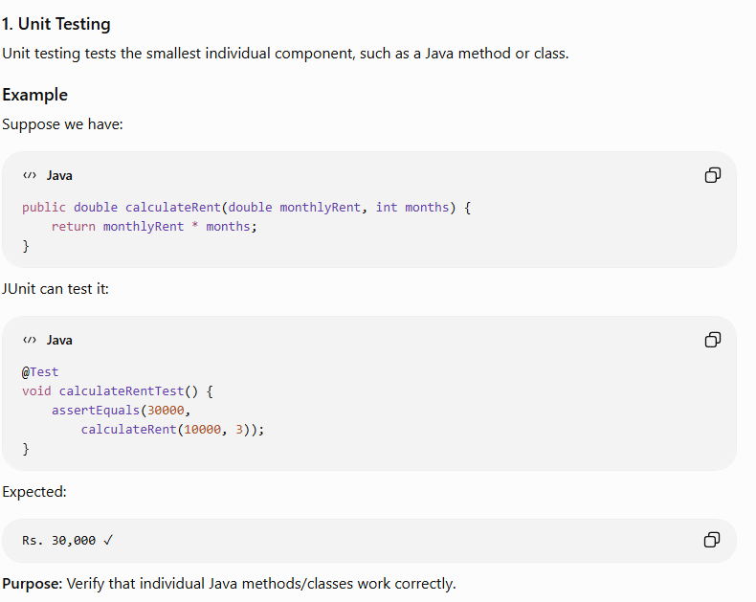
- Test cases , Test stubs and Drivers

Test Cases, Test Stubs and Test Drivers

1. Test Case
A test case is a set of inputs, conditions, steps, and expected results used to verify whether a software function works correctly.

Example: Room Rent Calculation
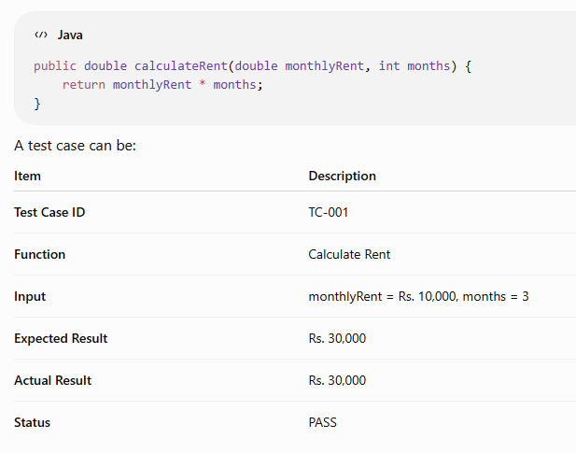If the actual result is Rs. 20,000:
Expected Result ≠ Actual Result → Test Failure → Defect is reported

Main purpose
Test cases help to:
- Verify requirements
- Find defects
- Ensure correct functionality
- Provide repeatable testing
- Document testing activities

2. Test Stub
A test stub is a temporary program that simulates a lower-level module that is unavailable or not yet developed.

Easy definition:
Stub = Fake module that is called by the module under test.

Room Rent Example
Suppose we are testing:
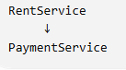
But the actual PaymentService has not been developed yet.
We create:
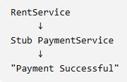
The stub can return a predefined response such as:
Payment Successful
This allows us to test RentService without waiting for the real payment module.
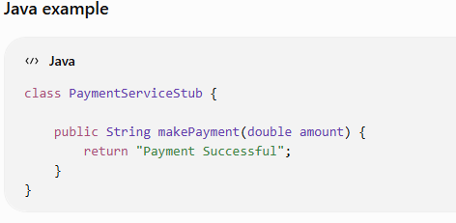
The stub does not perform a real payment. It simply simulates the payment service.

Mainly used in:
Top-Down Integration Testing

3. Test Driver
A test driver is a temporary program that calls the module being tested when the actual higher-level module is unavailable.

Easy definition:
Driver = Fake calling program that calls the module under test.

Room Rent Example
Suppose RentService is ready, but TenantController has not been developed.
We can create:
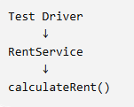
The driver supplies test data:
monthlyRent = Rs. 10,000
months = 3
and checks the result:
Expected = Rs. 30,000

Java example
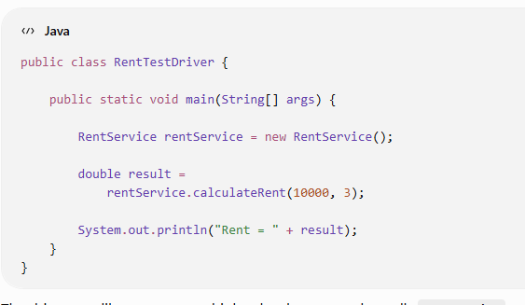
The driver acts like a temporary higher-level program that calls RentService.

Mainly used in:
Bottom-Up Integration Testing

- Describe the Test Stub and Test driver. Why and how integration testing is carried out? Explain.

Test Stub, Test Driver and Integration Testing

1. Test Stub
A test stub is a temporary program/module that simulates a lower-level module that has not yet been developed or is not available.

Simple idea:
Stub = Pretends to be the called module.

Room Rent Example
Suppose we are testing:
RentService → PaymentService
But PaymentService is not ready yet.
We create a stub PaymentService that simply returns:
"Payment Successful"
So we can test RentService without waiting for the actual payment module.
RentService
↓
Stub PaymentService
↓
"Payment Successful"
Mainly used in: Top-Down Integration Testing

2. Test Driver
A test driver is a temporary program that calls and supplies input to the module being tested when the higher-level module is not yet available.

Simple idea:
Driver = Pretends to be the calling module.

Room Rent Example
Suppose RentService is ready, but the actual TenantController is not ready.
We create a test driver that directly calls:
calculateRent(10000, 3)
Expected result:
Rs. 30,000
Test Driver
↓
RentService
↓
Rs. 30,000
Mainly used in: Bottom-Up Integration Testing

3. Difference Between Stub and Driver
Feature | Test Stub | Test Driver
Purpose | Simulates a called module | Simulates a calling module
Acts as | Lower-level module | Higher-level module
Used mainly in | Top-Down Testing | Bottom-Up Testing
Direction | Called by module under test | Calls module under test
Example | Fake PaymentService | Program that calls RentService

Easy memory:
Stub = stands below
Driver = drives/calls from above

4. Why is Integration Testing Carried Out?
Integration testing is performed after individual modules have been unit-tested. Its purpose is to check whether the modules work correctly together.
Even if every module works independently, problems may occur when they are combined.

Main reasons:

1. Detect interface errors
Different modules may exchange data incorrectly.
Example:
RentService → PaymentService
RentService sends 10000, but PaymentService expects the amount in another format.

2. Detect data communication errors
Data may be lost or incorrectly transferred between modules.
Example:
Tenant → RentService → Database
The payment may be successful, but the database may fail to update the payment status.

3. Detect interaction problems
Two individually correct modules may produce incorrect results when working together.
Example:
RoomAllocation → RentCalculation
The room is allocated correctly, but the wrong monthly rent is passed to the calculation module.

4. Detect side effects
A change in one module may unexpectedly affect another module.
Example:
Changing the payment module might accidentally affect receipt generation.

5. How Integration Testing is Carried Out
The general process is:
Unit Tested Modules
↓
Select Modules
↓
Integrate Modules
↓
Run Integration Tests
↓
Find Interface/Interaction Errors
↓
Fix Defects
↓
Retest
↓
Add More Modules

6. Types of Integration Testing

A. Top-Down Integration Testing
Integration starts from the top-level module and moves downward.
If lower-level modules are unavailable, stubs are used.

Room Rent Example
TenantController
↓
RentService
↓
Stub PaymentService
↓
Stub Database
As real modules become available, the stubs are replaced.

Remember:
Top-Down → Uses Stubs

B. Bottom-Up Integration Testing
Integration starts from the lowest-level modules and moves upward.
If higher-level modules are unavailable, drivers are used.

Room Rent Example
Test Driver
↓
PaymentService
↓
RentService
↓
TenantController
As higher-level modules become available, the drivers are removed.

Remember:
Bottom-Up → Uses Drivers

C. Sandwich / Hybrid Integration Testing
It combines Top-Down and Bottom-Up approaches.
Top Modules
↓
↓ ↓ ↓
─────────────
Target Layer
─────────────
↑ ↑ ↑
Lower Modules
Testing proceeds from both directions and eventually meets in the middle.

Advantage:
It can reduce testing time for large and complex systems.

7. Regression Testing During Integration
Whenever a new module is integrated, previously tested functionality should be tested again.

Example
Initially:
Tenant → Room → Rent
Later, Payment is added:
Tenant → Room → Rent → Payment
After adding Payment, we should check that:
- Tenant registration still works ✓
- Room allocation still works ✓
- Rent calculation still works ✓
- Payment works ✓
This is Regression Testing.

8. Complete Room Rent Example
Suppose our Java application contains:
TenantController
↓
TenantService
↓
RentService
↓
PaymentService
↓
PostgreSQL

During Top-Down Integration:
If PaymentService is not ready:
TenantController
↓
TenantService
↓
RentService
↓
Stub PaymentService

During Bottom-Up Integration:
If TenantService is not ready:
Test Driver
↓
RentService
↓
PaymentService
↓
Database
Thus, stubs and drivers allow testing to continue even when all modules are not yet available.

Exam Conclusion
Test stubs and test drivers are temporary scaffolding programs used during integration testing. A stub simulates a called lower-level module, whereas a driver simulates a calling higher-level module. Integration testing is carried out to identify interface, data communication, interaction, and side-effect errors between individually tested modules. Common approaches include Top-Down, Bottom-Up, and Sandwich integration testing, supported by regression testing to ensure that newly integrated modules do not break existing functionality.

- CASE Tools for configuration management

CASE Tools for Configuration Management
CASE = Computer-Aided Software Engineering.
CASE tools for configuration management provide automated support for controlling, tracking, and maintaining changes to software and its related documents throughout the software development life cycle.
Modern examples include Git, GitHub, GitLab, Jenkins, Maven, and Gradle. They have changed configuration management from a mostly manual process into an automated, traceable, and collaborative process.

1. Automatic Version Control
Tools such as Git maintain the history of changes made to software configuration items.
Example:
Version 1.0
↓
Version 1.1
↓
Version 1.2
Developers can see:
- Who made the change
- When it was made
- What was changed
- Why it was changed
This makes version management easier and more reliable.

2. Branching and Merging
CASE/SCM tools allow different developers to work on different features simultaneously.
main
|
┌──────┴──────┐
↓ ↓
rent-feature payment-feature
↓ ↓
└──────┬──────┘
↓
merge
↓
main

Room Rent Example
One developer works on Rent Calculation, while another works on Online Payment. They can develop these features separately and later merge them into the main version.

3. Rollback
If a new version introduces a serious problem, configuration management tools allow the team to return to a previous stable version.
V1.0 ✓
↓
V1.1 ✓
↓
V1.2 ✗
↓
Rollback
↓
V1.1 ✓
This reduces the risk associated with software changes.

4. Automated Build
Tools such as Maven and Gradle automate the process of compiling Java code, managing dependencies, running tests, and creating build packages.
Java Source Code
↓
Maven
↓
Compile
↓
Run Tests
↓
Build JAR
This ensures that software is built consistently.

5. Continuous Integration
Modern CASE/SCM tools support Continuous Integration (CI). Whenever developers commit changes, the system can automatically build and test the software.
Developer
↓
Git Commit
↓
CI Server
↓
Build
↓
Automated Tests
↓
Success / Failure
This helps identify integration problems early.

6. Automated Release Management
CASE and DevOps tools can automate the movement of software through different environments.
Development
↓
Testing
↓
Approval
↓
Release
↓
Production
This makes software releases faster, consistent, and less error-prone.

7. Traceability and Audit Trail
Configuration management tools maintain a detailed history of changes.
For example:
Requirement CR-101
↓
Git Commit
↓
Code Change
↓
Test Case
↓
Version 1.1
↓
Release
The team can determine what was changed, who changed it, when it was changed, and which release contains the change.

Conclusion
CASE tools for configuration management provide automated support for version control, branching and merging, rollback, build automation, continuous integration, traceability, and release management. They have transformed configuration management from a mostly manual process into an automated, collaborative, and traceable process, enabling software teams to incorporate changes quickly while maintaining quality, consistency, and control.

- Explain the process of incorporating change in development process. How has CASE tools changed the process of version and release management in present context? Discuss in brief.

Incorporating Change in Software Development and Role of CASE Tools
Software is never completely static. Customer requirements, business rules, technology, and regulations change continuously. Therefore, changes must be controlled systematically so that they do not introduce new defects or affect existing functionality.
This process is mainly handled through Software Configuration Management (SCM).

1. Process of Incorporating Change
The basic process can be remembered as:
Change Request → Impact Analysis → Approval → Implementation → Testing → Review → New Version/Release

Step 1: Identify the Change
A change may be required because of:
- New customer requirements
- Bug or defect
- Security problem
- Change in business rules
- Performance improvement
- New technology
Room Rent System example:
The landlord requests:
"Add a late-rent penalty of Rs. 500 if rent is paid after the due date."

Step 2: Submit a Change Request
The customer, user, developer, or manager submits a formal Change Request (CR).
Example:
CR-101
Change: Add late-rent penalty
Reason: Encourage timely payment

Step 3: Impact Analysis
The development team determines:
- Which modules will be affected?
- What will be the development cost?
- How much time is required?
- Will existing functionality be affected?
- What testing is required?
Room Rent example:
Late Penalty
↓
Rent Calculation
↓
Payment
↓
Invoice
↓
Database
Several components may need modification.

Step 4: Change Approval
The responsible authority, such as a Change Control Board (CCB) or project manager, reviews the request.
If the change is:
- Necessary
- Feasible
- Affordable
→ Approve
Otherwise → Reject/Postpone

Step 5: Implement the Change
After approval, developers modify the required software components.
For example:
if (paymentDate > dueDate) {
penalty = 500;
}
The change is implemented according to the approved request.

Step 6: Test the Change
The modified software is tested to ensure:
- The new feature works.
- Existing functionality still works.
- No new defects have been introduced.
For example:
Situation | Expected
Rent paid before due date | No penalty
Rent paid on due date | No penalty
Rent paid late | Rs. 500 penalty

Step 7: Review and Audit
The team verifies that the implemented change matches the approved change request.
This is known as configuration auditing.

Step 8: Create a New Version/Release
After successful testing, the changed software is assigned a new version.
Example:
Version 1.0 → Original Room Rent System
Version 1.1 → Late-rent penalty added
Version 1.2 → Online payment added
Version 2.0 → Major redesign

2. How CASE Tools Changed Version and Release Management
CASE = Computer-Aided Software Engineering.
CASE tools provide automated support for software development and configuration management.
Modern examples include Git, GitHub, GitLab, Jenkins, Maven, Gradle, etc.
They have changed version and release management from a mostly manual process into an automated, traceable, and collaborative process.

Major Changes

1. Automatic Version Control
Tools such as Git maintain the history of changes.
Example:
Version 1.0
↓
Version 1.1
↓
Version 1.2
Developers can see:
- Who made the change
- When it was made
- What was changed
- Why it was changed

2. Branching and Merging
Different developers can work on different features simultaneously.
main
|
┌──────┴──────┐
↓ ↓
rent-feature payment-feature
↓ ↓
└──────┬──────┘
↓
merge
↓
main
Room Rent example:
One developer works on Rent Calculation, while another works on Online Payment.
They can later merge their work.

3. Rollback
If a new version introduces a serious problem, the team can return to a previous stable version.
V1.0 ✓
↓
V1.1 ✓
↓
V1.2 ✗
↓
Rollback → V1.1 ✓
This greatly reduces risk.

4. Automated Build
Tools such as Maven and Gradle can automatically compile Java code, manage dependencies, run tests, and create build packages.
For example:
Java Source Code
↓
Maven
↓
Compile
↓
Run Tests
↓
Build JAR

5. Continuous Integration
Modern tools can automatically build and test software whenever developers commit changes.
Developer
↓
Git Commit
↓
CI Server
↓
Build
↓
Automated Tests
↓
Success / Failure
This helps identify integration problems early.

6. Automated Release Management
CASE/DevOps tools can automate the movement from:
Development → Testing → Production
Code
↓
Build
↓
Test
↓
Approve
↓
Release
↓
Production
This makes releases faster and more consistent.

7. Traceability and Audit Trail
Tools maintain a history of changes.
For example:
Requirement CR-101
↓
Git Commit
↓
Code Change
↓
Test Case
↓
Version 1.1
↓
Release
This makes it easier to determine exactly what changed in a release.

3. Traditional vs Modern Version Management
Traditional Approach | Modern CASE/SCM Approach
Manual version tracking | Automated version control
Files copied manually | Repository-based management
Difficult rollback | Easy rollback
Limited change history | Complete change history
Difficult collaboration | Branching and merging
Manual builds | Automated builds
Manual testing | Automated testing/CI
Manual releases | Automated CI/CD releases
Difficult traceability | Detailed audit trail

4. Simple Room Rent Example
Suppose the original system is:
Room Rent System v1.0
A landlord requests online rent payment.

Change process:
Change Request
↓
Impact Analysis
↓
Approval
↓
Developer creates branch
↓
Implement Online Payment
↓
Automated Testing
↓
Code Review
↓
Merge
↓
Build
↓
Release v1.1
If the new payment feature causes a serious problem:
v1.1 ✗
↓
Rollback
↓
v1.0 ✓
This demonstrates how modern tools make change, versioning, and release management much safer and faster.

Conclusion
Incorporating change is a controlled process involving change identification, request submission, impact analysis, approval, implementation, testing, auditing, and release of a new version. CASE and modern SCM tools have significantly improved this process by providing automated version control, branching and merging, rollback, build automation, continuous integration, traceability, and automated release management. As a result, software teams can incorporate changes more quickly while maintaining quality, consistency, and control.

Easy exam memory
Change Process:
I → R → A → I → T → A → R
- I = Identify change
- R = Request
- A = Analyze/Approve
- I = Implement
- T = Test
- A = Audit
- R = Release

